**Sushi Startup Location Aid**

Abel Kim

7/1/2020

**Business Problem**

A restaurant owner is thinking of opening up a second Japanese sushi restaurant in a new location. He wants to open up his business in Austin, but he is unsure of where the location should be. He wants the location to not have much competition, but at the same time have evidence of similar restaurants being successful in the chosen area. By using the Foursqaure location data, we can create a program that will show the restaurant owner a visual representation of the Japanese sushi restaurants within the city (divided by generated clusters) and help aid in his decision of finding his restaurant’s location.

In this case, the project was made for this one restaurant owner in mind, but the location and restaurant type can be tweaked so that it can be applicable for any restaurant owners looking to open up a new restaurant.

**Data**

For this project, we will only be using the Foursquare API location data. We will import the data of Austin venues and only use the data of Japanese sushi restaurants. From there, we will format the chosen data onto a map for visual reference and observe the clusters formed to determine the ideal place for the new restaurant.

**Methodology**

For the database, I used the Github repository.

To visualize the data, I used the Folium library to create a map of Austin, Texas, and using the Foursquare API, I explored Austin's sushi restaurants and superimposed them onto the map below using their latitude and longitude values:

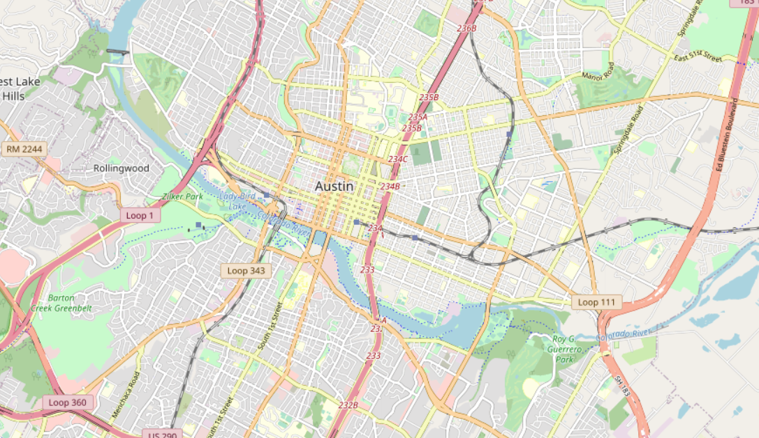

After the map was generated, I used the K-means algorithm to organize the restaurants into clusters, which resulted in the following clusters:

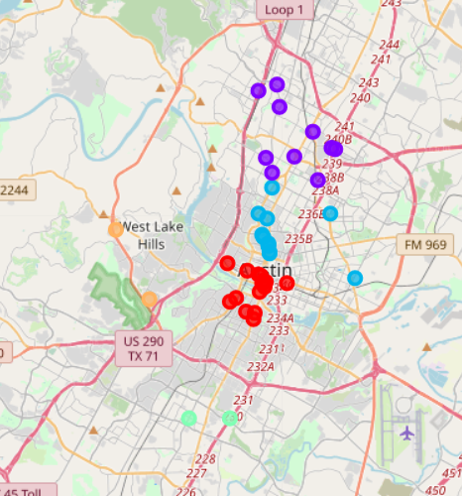

**Results**

After running the K-means algorithm, the restaurants were grouped into 5 distinct clusters. The red cluster consists primarily of restaurants in or near Downtown Austin, so I will refer to the red cluster as the “Downtown Cluster.” Likewise, I will refer to the blue cluster as the “University Cluster” due to their proximity to UT Austin. For the purple, orange, and green clusters I will refer to them as the “North Cluster,” “West Cluster,” and “South Cluster” respectively.

**Discussion**

At first glance, we can disregard the West and South Clusters as possible places to open up a sushi restaurant as they each have only 2 restaurants in the cluster, which may suggest that sushi restaurants are not too sought after in those areas. On the other hand, the Downtown, University, and North clusters have a fair amount of sushi restaurants within their clusters, so we will be examining these three clusters further to determine where a sushi restaurant should be opened.

First, let us start out by considering the Downtown Cluster. This cluster appears to be the densest out of all of the generated clusters, which suggests that these sushi restaurants are fairly close to each other, and would thus have a higher amount of competition when compared to the University or North clusters. Besides that attribute, downtown areas in cities are, in general, expensive to rent. For these reasons, we can disregard the Downtown Cluster as a potential location for the restaurant.

Next, let us consider the University Cluster. At first glance, the cluster seems pretty spaced out and would suggest a smaller amount of competition when compared to the Downtown Cluster. However, the cluster is a bit misleading as the big empty space in the middle of the cluster is the UT Austin campus. If we consider the fact that the empty space in the middle cannot be used for a restaurant, then the only applicable places for the restaurant would be by the clump of restaurants on the left side of the cluster (which would suggest higher competition) or the right side of the cluster (which is not ideal as it is near a noisy highway). Another fact to consider is that the surrounding area is a University, which would mean a large portion of the restaurant’s customer base would be students. If the restaurant owner wants to open up a new sushi place, the main customer base should be working adults who can afford to go to sushi places on a more frequent basis. From these considerations, we can exclude the University cluster as a potential restaurant location.

Finally we are left with the North cluster. When looking at the cluster, it seems pretty spread out, suggesting that the competition would be pretty lax. Given that we excluded the other four clusters, the North cluster seems to be the best place to open a restaurant,

**Conclusion**

Through process of elimination and the aid of the map clusters, the best place for the restaurant owner to open up his sushi restaurant would be in the North Cluster.